Michael Tracy

CSD 340 Web Development with HTML and CSS

Assignment 1-2

3/16/2023

Here is a link to my github repository: [techevil441/csd-340: repository for my HTML class at Bellevue (github.com)](https://github.com/techevil441/csd-340)

Here are the required screenshots, first, my github repository:

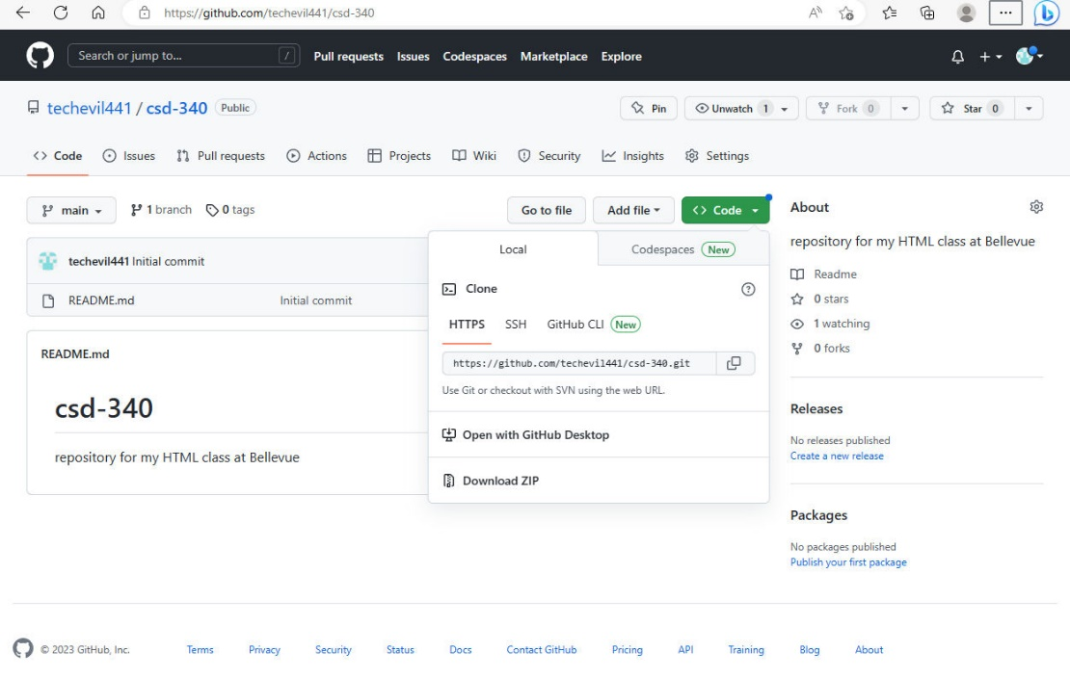

Next, my local directory:

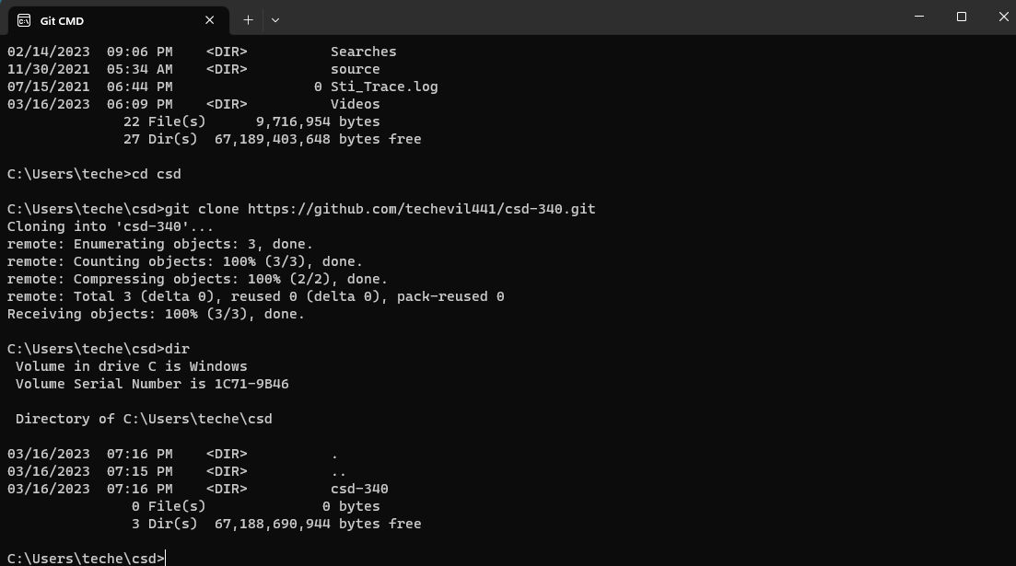

Hope this is what you wanted!